Creativity and the Digital World
Creating a Claymation with Photo Editing

Due by the end of lab during week 12. Weeks 11-12

Learning Objectives
- Practice creative thinking
- Learn to create an unconventional claymation.
- Additional experience using Photoshop.
- Additional experience with animation.
What to do:
- Before creating your clay figures, document your creative process on your creativePlanning.html page:
  - Describe the techniques that you used to expand your thinking out of the conventional.
  - How did you generate ideas? (preparation) Eg Brainstorming, web search, list favorite movies, and so on.
  - How did you transform your ideas? Eg exaggeration, synthesizing unrelated ideas, anthropomorphizing, role reversal etc.
  - How is your idea different from a conventional idea?
  - How will you use this creative work (animation) on your web site?

- I will post the images of your clay figure(s) to Moodle for you to work with during lab the following week (or before, if you like).
For example the following Pictures where used to create one student’s claymation:
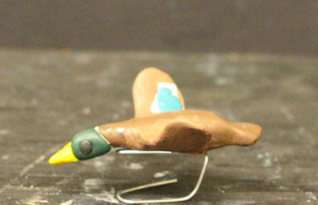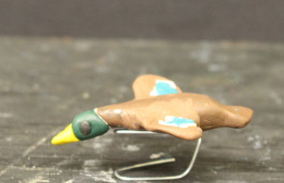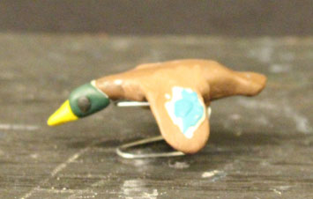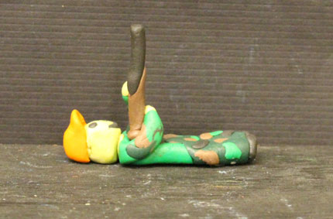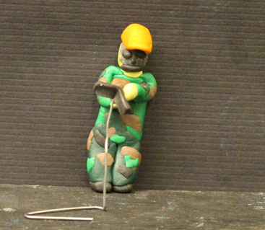
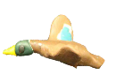
- Using Photoshop extract your objects from the photos, as follows using ‘Save for Web”. Save as either .gif or .png.
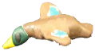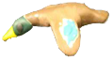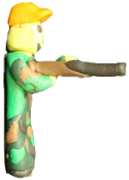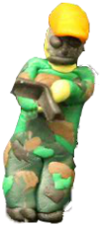
- Use Adobe Animate to move your objects against a suitable background. Create a layer for each object that moves and the background, as follows:
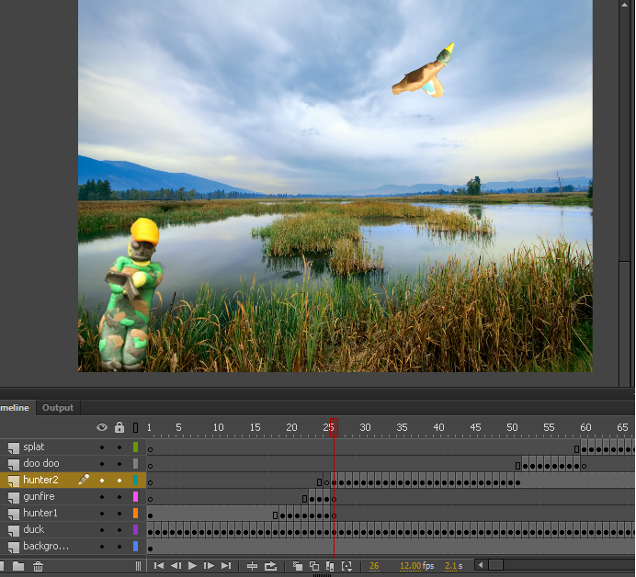
- Import your images into Animate:
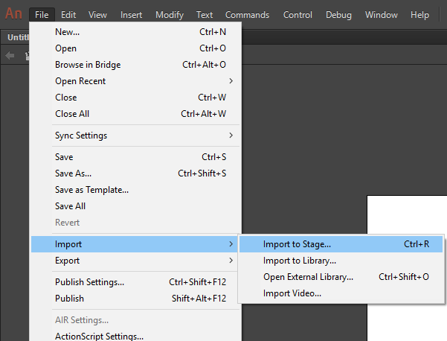
- Remember use F6 to record changes when moving or replacing images.
You may want to adjust the timing of how your frames play by inserting regular frames (F5) to get something like this:
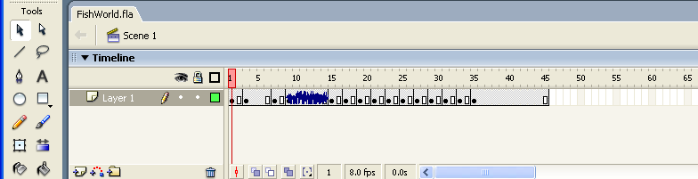

- When your claymation plays the way you wish, export the movie file to your Home folder as a (SWF) Flash Movie (swf), and add this to your web page.:
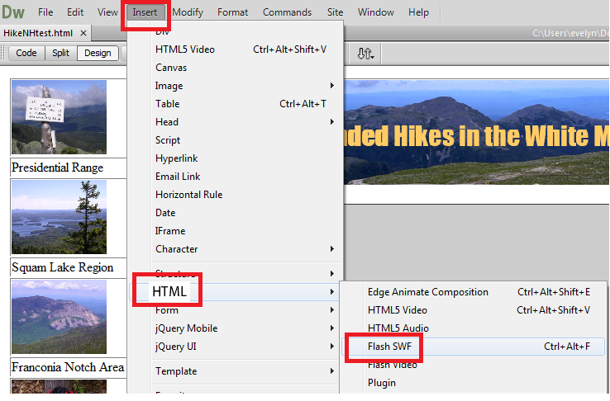

- Test your moving using Internet Explorer.
- In your creativePlanning.html page let me know where on your website you have your claymation or place a link directly to it.

How you will be evaluated:
To receive credit for this lab, attend lab on both lab days and use lab time well, and update your creativePlanning page to let me know where your claymation is located and describe your creative process.
Your claymation exhibits creativity and shows quality work and you have a detailed creative process documented in creativePlanning.html. A
Your claymation works but is moderately creative and you have a moderately creative process documented in creativePlanning.html. B
Your claymation works: C

