Testimonials and Pictures from Recent Trip to the Dominican Republic
Faculty Leader- Matthew Toms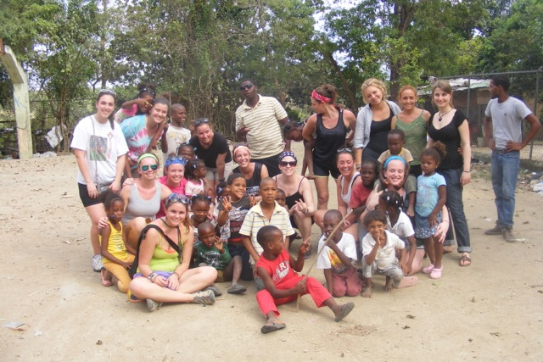
The entire PSU group in "La Duquesa", a batey just outside of Santo Domingo

“The first thing that comes to mind when I think of my experience in Santo Domingo is team work. The short term abroad was like no other; it was the experience of a lifetime. Going to the Dominican Republic is an indescribable opportunity and you must experience it for yourself! You make new relationships, expand your horizons, become globally educated and can continue to spread awareness. Be the change."

Marisa Silva
Plymouth State University 2015
" Go confidently in the direction of your dreams. Live the life you have imagined.”
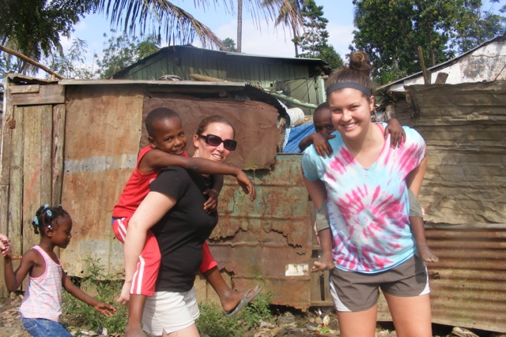

Pictured above- Katie Hulett and Christine Labore

“The trip to the Dominican Republic moved me in so many ways, I could write about it forever. It put a lot of things in my life into perspective, and put me on track with where I’m going and what I want to do with my life, and how I want to make a change in others’ lives. I have experienced a lot in my life; I have traveled to many places but one thing I had never seen before was poverty. It was like being in one of those sad commercials and not being able to quickly change the channel. I plan to return to the Dominican for the rest of my life. I want to grow in my Spanish, and return and coach sports, do arts and crafts, and give the kids opportunities that they deserve to have. It was sad, intense, and amazing all in one. Yes, they live in complete filth, but there is such beauty in the culture and the people there. We may have everything and more than we even need, but in America people always find something to complain about. In the Dominican they don’t have what they need or want and they never find a reason to complain. They love one another and there is such beauty in the people that it makes me want to come back. Yes, they need a lot of help and I can’t wait to make a change for them, and I will continue to make small changes for the rest of my life.”
Courtney Daley - Adventure Ed. - Class of 2015

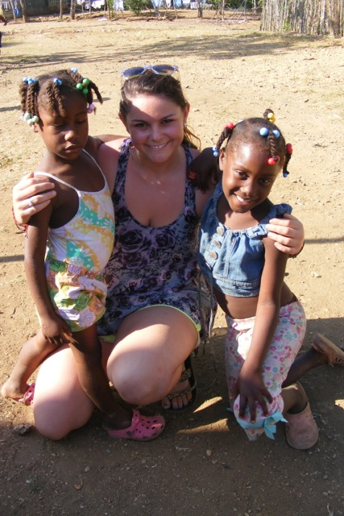
Pictured Above- Courtney Daley

