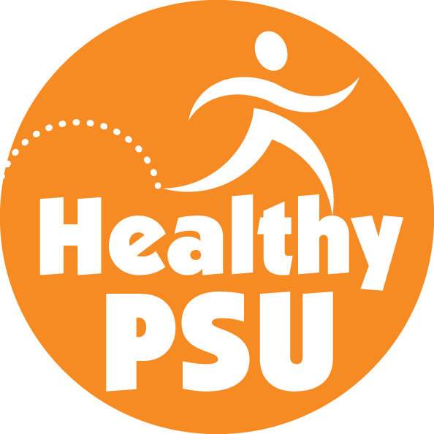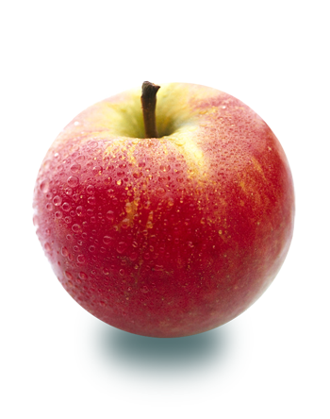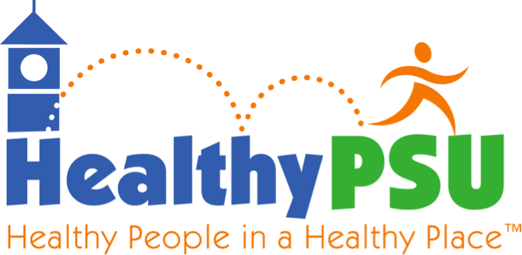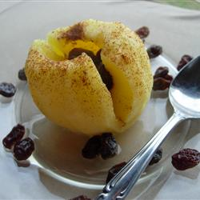

Run or hike 12.2 miles

[www.squamlakes.org](http://www.squamlakes.org)

More Info: [www.memoriesalive.org](https://mail.plymouth.edu/zimbra/www.memoriesalive.org" \t "_blank)

Sept. 22nd, 7:45 am

##### **Squam Ridge Run**

10:30 am - 2:30 pm

HUB Hage Room

Oct. 24th

Sept. 14th , 2-9 pm

##### **14th Annual Day to Fight Cancer Fun Walk**

##### **Healthy Returns**

#### Save the Date!

* Maintain & grow successful physical activity programming:
  + PSU Walks
  + Faculty & Staff Fitness Classes
  + Employee Personal Training Program
* Increase healthy food options on campus for PSU employees
* Begin steps towards a smoke-free campus

### Welcoming Another Academic Year

Healthy PSU

Healthy People in a Healthy Place

September 2013

# Goals for 2013-2014:

This time of year is always exciting as the air become cooler, leaves begin to turn color and students return to campus – bringing a renewed energy & spirit to PSU!

For those of you who were away over the summer, here are some of the things that went on over the last few months:

* New Summer Hours at the HUB Fitness Room
* Zumba & Yoga Classes for Employees
* Local Foods Tradeshow
* Mindfulness Workshops

We look forward to another healthy year ahead and welcome any and all of your feedback and suggestions as we continue to move forward. Email us at: [healthy-psu@plymouth.edu](mailto:healthy-psu@plymouth.edu)

Everything you need to know about how to be healthier at work & in our community can be found at:

<http://www.plymouth.edu/healthy-psu/resources/>

**Fall Fitness Classes**

Look for announcements coming soon on more employee-focused physical activity classes. Offerings will likely include spin classes and yoga.

**Meditation Mondays**

Mondays 12:20-12:45 pm (excluding holidays). Different meditation practices each week. No experience necessary – all are welcome.

**PSU Walks**

***Are you interested in getting more daily physical activity, but don’t feel like you have the time or know how to do it?*** Consider joining our PSU Walks program. Get a free pedometer, learn how to set goals and slowly increase your daily physical activity. Rewards include Healthy PSU water bottles, t-shirts and free exercise psychology consulting.

Contact Jill: [jytarkleson@plymouth.edu](mailto:jytarkleson@plymouth.edu)

**Eat Local – Eat Healthy**

With the farmer’s market coming to an end, continue to buy fresh, local produce & goods each week with Local Foods Plymouth. Log on to <http://localfoodsplymouth.org/> between Sun-Tues, buy your products, & pick them up Thursday afternoons from 4-6 pm at the UPS Store on Main Street.

**LFP “Five and Ten” Package**

Another option for eating local this fall, purchase the LFP “Five and Ten” package. For 10 weeks, beginning September 12th, receive 5 of the following products for $300 or all 6 for $330 – cheese, milk, meat, bread, eggs & veggies. All from local farms – pick-up at UPS Store on Thursday afternoons.

For more information: <http://localfoodsplymouth.org/>

# Microwave Baked Apple

*Core and peel your apple – leave the bottom skin intact. In a bowl, mix brown sugar, nutmeg & cinnamon together. Pour mixture into apple core & top with butter. Put in deep microwaveable bowl & cover. Microwave for 3 ½ to 4 minutes. Let cool before eating. Add dried fruit, nuts or granola if you’d like. Enjoy!*

**1 apple, cored**

**1 Tbsp brown sugar**

**½ tsp ground nutmeg**

**½ tsp cinnamon**

**1 tsp butter**

###### A fast & easy way to enjoy one of this season’s most abundant fruits.