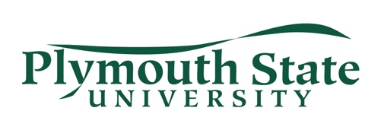
2019 NEBDI Enrollment Form
July 11-13, 2019
Name _______________________________________ Phone ____________________
Home Address ________________________________________________________________________
________________________________________________________________________
School ________________________________________________________________________
Email ________________________________________________________________________
Instrument you will play in the Reading Sessions _____________________________________________
Are you attending NEBDI for Graduate Credit? Yes No 
(A registration form for graduate credit can be found on the New England Band Directors Institute web page. That form should be sent to the Office of the Registrar 17 High St, MSC #7 Plymouth, NH 03264. Payment for graduate credit is made by following the directions on the bottom of the graduate registration form., Checks are made payable to Plymouth State University. REGISTRATION FOR GRADUATE CREDIT NEEDS TO BE COMPLETED BY JULY 8TH (LAST DAY OF ADD/DROP FOR THE TERM). YOU WILL NOT BE ABLE TO REGISTER FOR GRADUATE CREDIT ON-SITE.)
Convention ENROLLMENT: $75.00 (Includes membership in the New Hampshire Band Directors Association for one year.)
$25.00 (For full-time enrolled students)
NEBDI Banquet: $20.00
*Enrollment and Banquet checks should be made payable to NHBDA
Please note: In order to be able to properly accommodate those who wish to attend NEBDI, the enrollment is limited. In order to reserve a spot, this form should be received by July 1.

Please mail enrollment form to:
Dr. James Chesebrough, NEBDI Coordinator
Department of Music, Theatre and Dance
Plymouth State University
17 High Street MSC 37
Plymouth, NH 03264

