Merchant Fleet Share Quick Start Sheet
Log in: your Plymouth email address
Here is what your login page will look like:
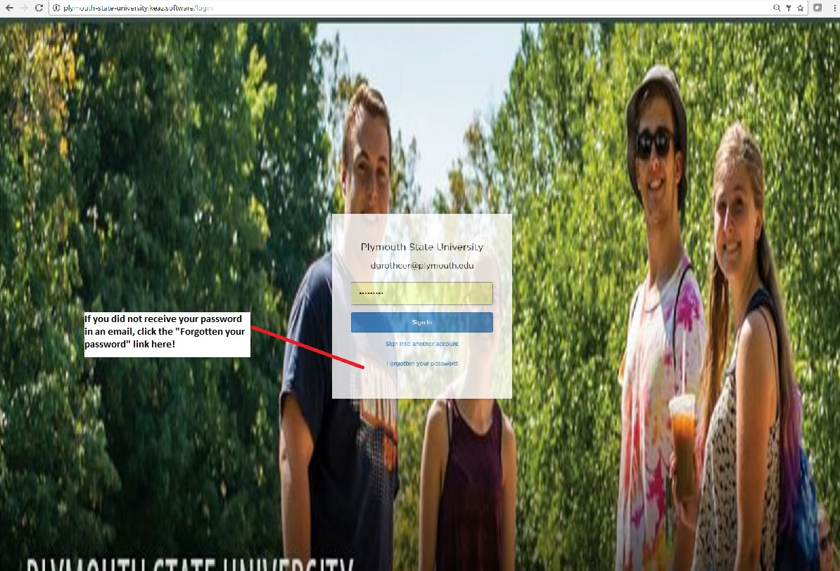
If you didn’t get a password email, go ahead and click “Forgotten your password” on the screen and you can set your password there.

Once you get logged into the Keaz system, you are all set to begin making reservations. This will be the first page you see. First thing you must do is to CLICK the link PLYMOUTH STATE UNIVERSITY, you see below. After, you are able to change the dates to what you are looking to reserve.
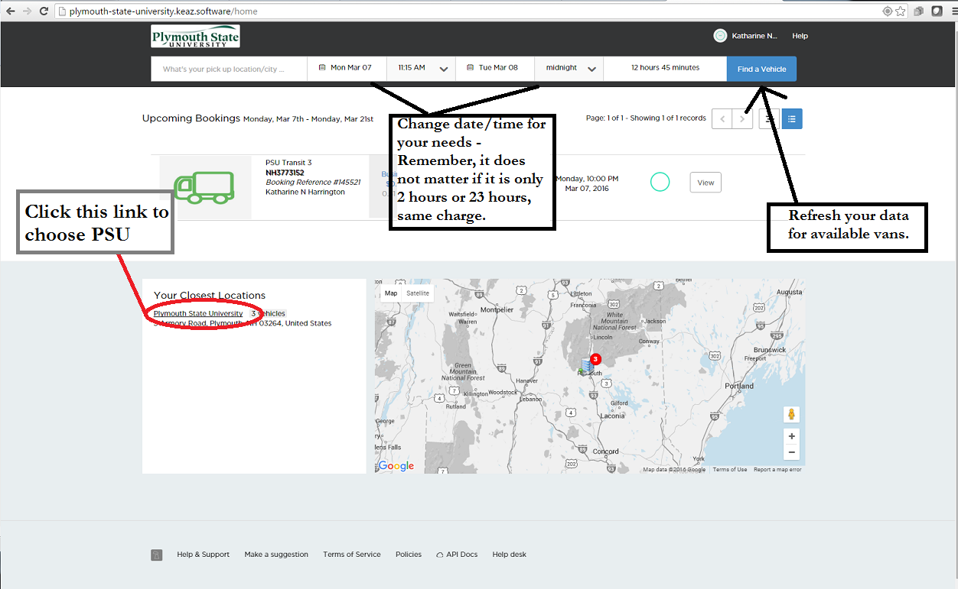
This sceen will SOMETIMES show up, be patient and it will go away. It is because the system is “pinging” the vans to see where they are and if there is a reservation in the system. If it does not go away, then contact the campus travel coordinator because the vans may be booked and we can sometimes get another van on campus for that time period.
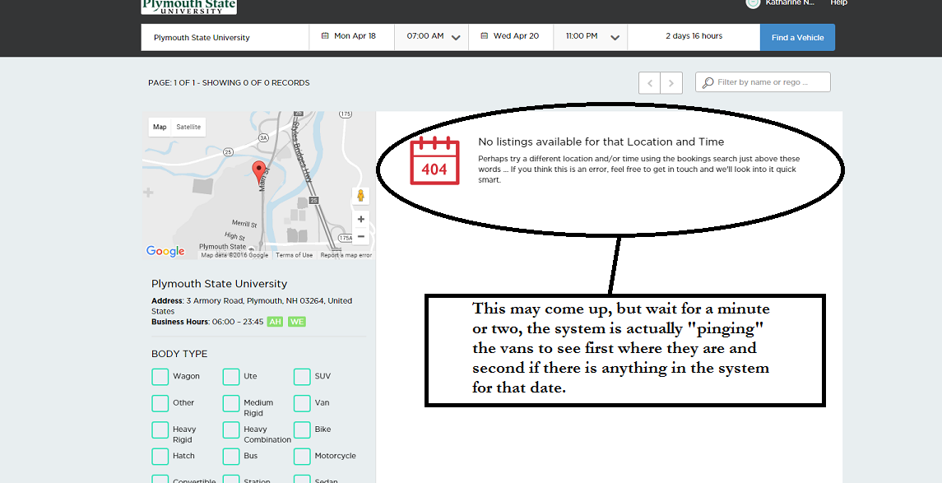

This page will show if there are vans available to reserve. Click the “BOOK NOW” button.
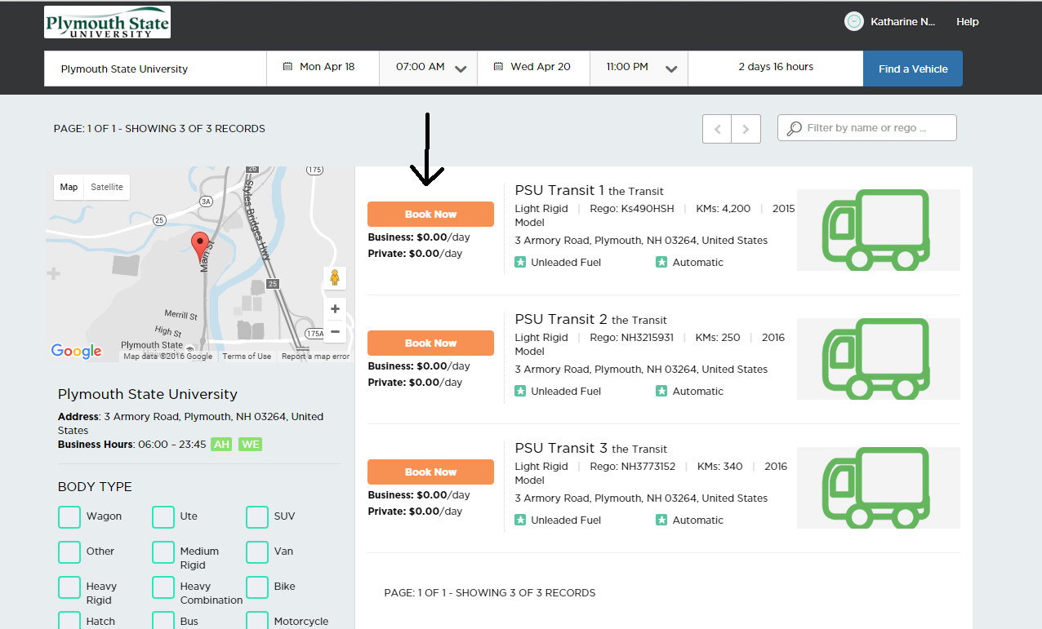
Here you can either book the van for yourself or another registered participant. Once you complete the reservation, you will get an email from the system confirming your reservation.
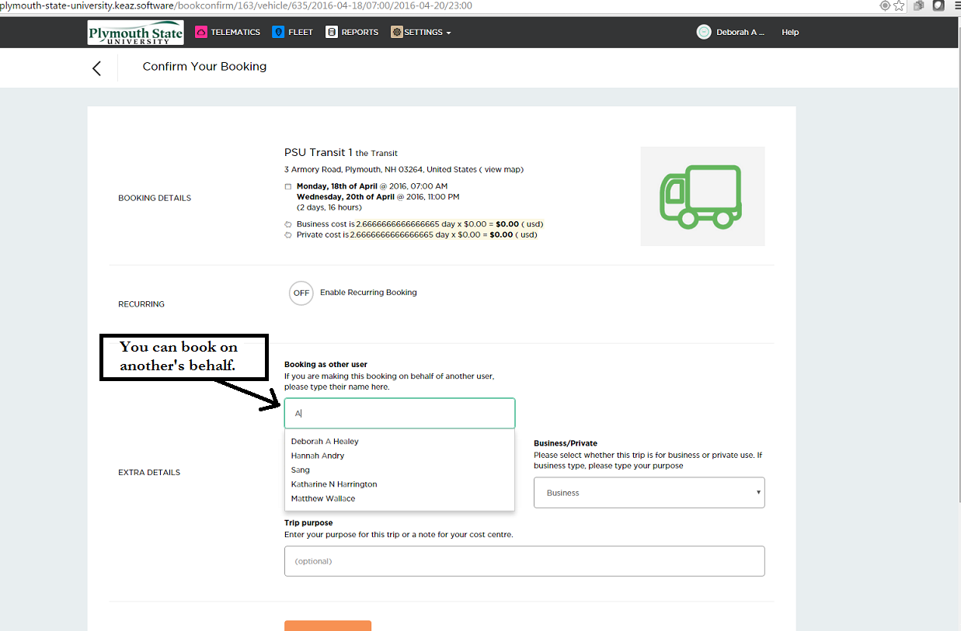

To add a NEW Driver, you need to choose SETTINGS / USERS on the main screen.
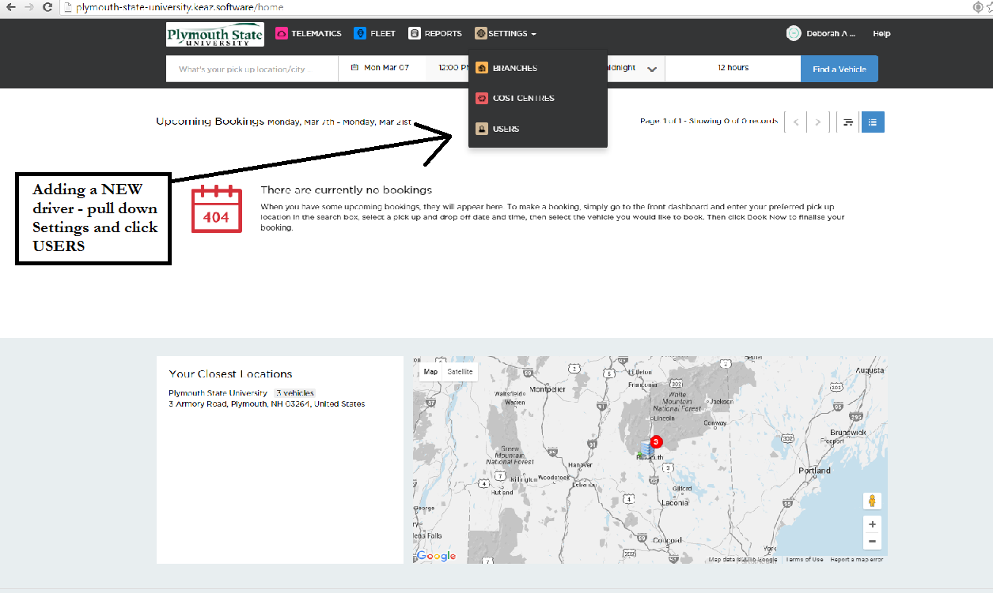
Then, Click the ADD USER button as seen below:
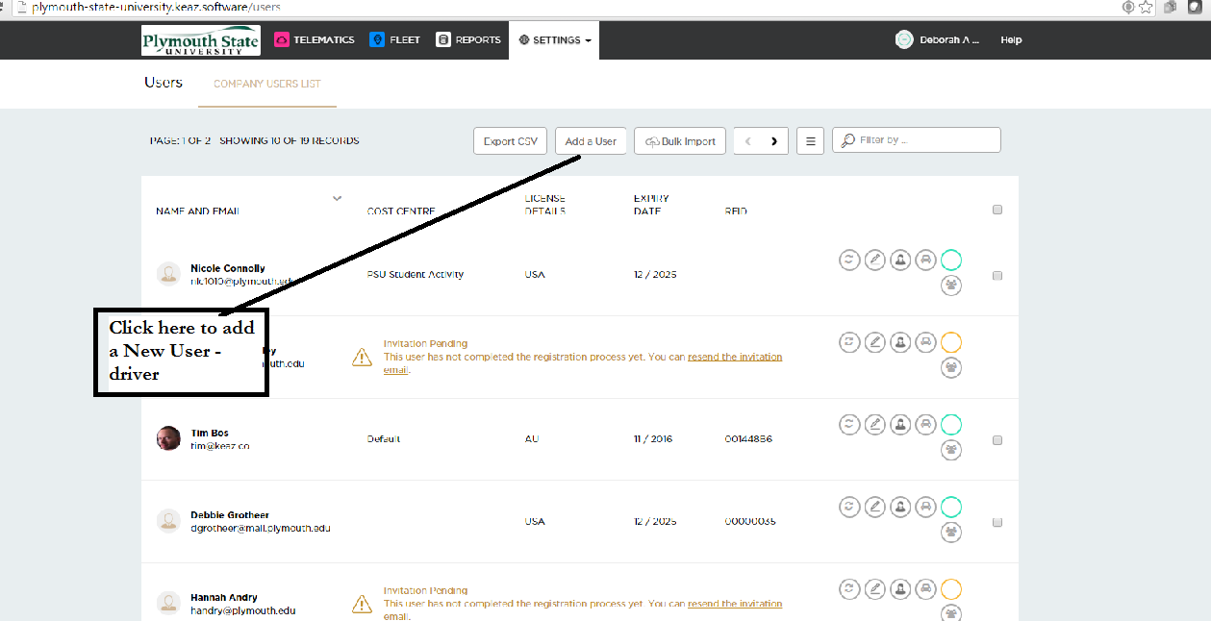

On this screen, add as much information that you have available. The RFID does not need to be entered until closer to the reservation date and then you want to set that individual with a specific card from the stock given to you by the campus travel coordinator. Then click SAVE to enter the user type and cost center.
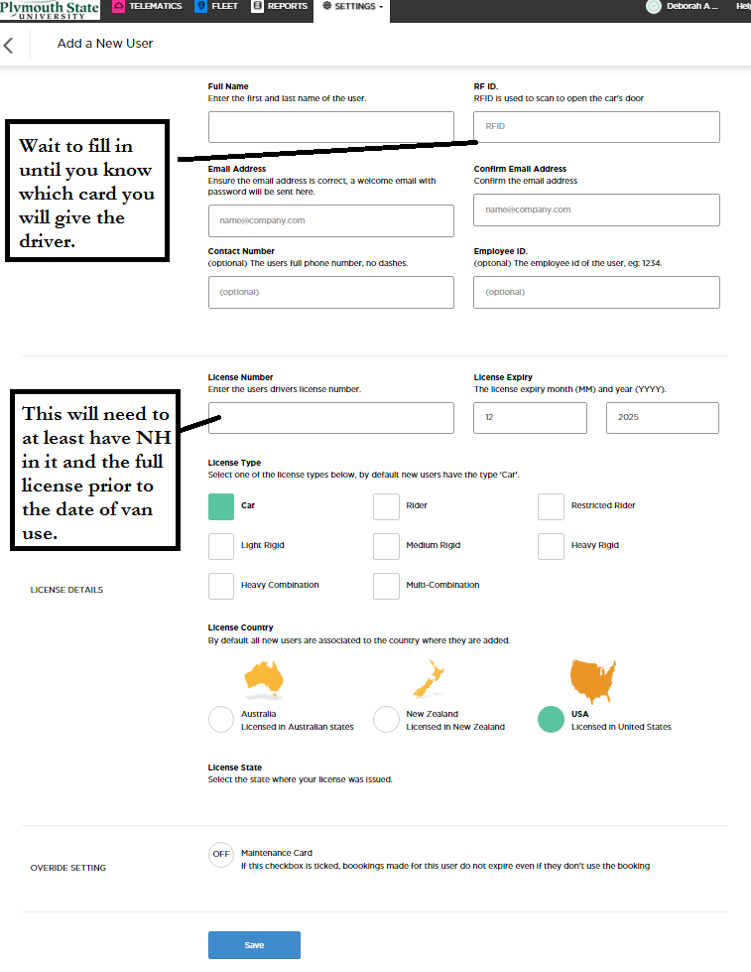

This is the next page you will see. You want to only choose “Driver Access” so that they are unable to reserve in someone else’s name. BEFORE YOU CLICK SAVE, CLICK THE “LOCATIONS” BUTTON TO SET COST CENTER!!
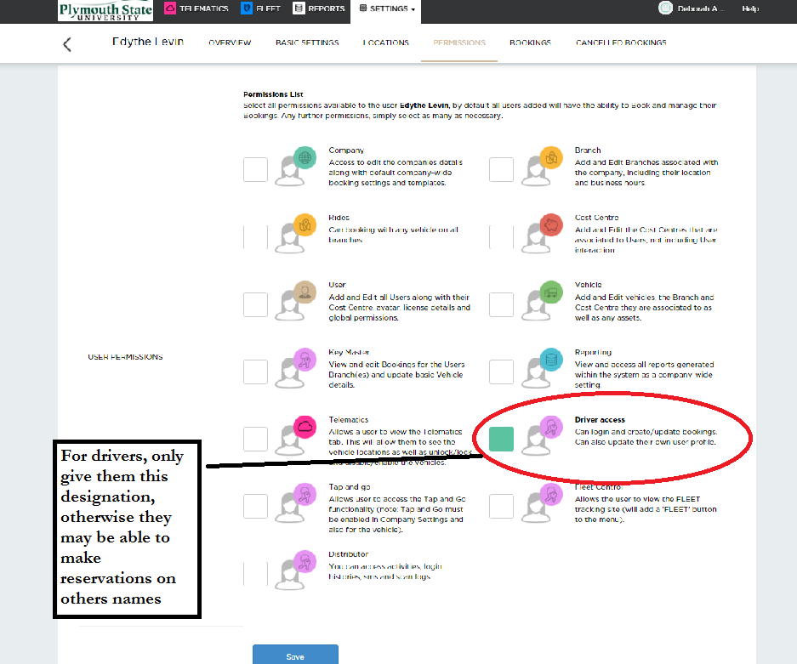
Once on this page, make sure you open all the Cost Centers to find yours, then save. The new user is now set up!