Social, Humanitarian, and Cultural Affairs
Committee
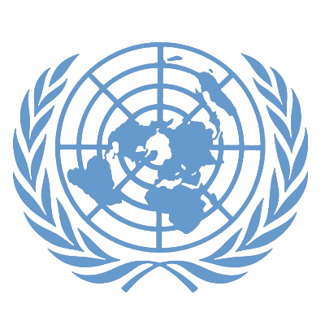
_____________________________________________

_______________________________________
5th Annual Plymouth State University
Model UN Conference

April 13th-14th, 2013

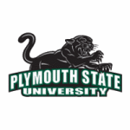
On behalf of Plymouth State University and the Plymouth State Model United Nations I would like to welcome you to the 5th annual PMUN Conference. We are happy to have new and returning delegates, advisors, and families come to our campus and participate in delegation. I, Kathleen Rosse, PMUN President, Secretary General, and the Social, Humanitarian, and Cultural Affairs committee chair am excited to welcome you all into the SOCHUM Committee and further more excited to hear what you have prepared for debate. Last year we were blown away by the creativity, the amount of preparation, and the high level of knowledge delegates brought to committee and cannot wait to hear what you have to say this year.
We have been working hard for months preparing this conference, building off of feedback and lessons learned from the years before. We hope to make this committee and conference the best to date making it a memorable experience for all. If you have any questions about the SOCHUM Committee, your nation assignments, or your position papers, please feel free to contact us at any time. We look forward to meeting you in April.

SOCHUM Committee Chair: Kathleen Rosse Contact: ksrosse@plymouth.edu

Social, Humanitarian, and Cultural Affairs Committee Overview
__________________________________________________________________

The Social, Humanitarian, and Cultural Affairs Committee (also known as the Third Committee) is one of the six main committees of the General Assembly in the United Nations. This organ of the UN was created shortly after the creation of the Universal Declaration of Human Rights in 1948. Typically, the General Assembly will allocate agenda items to this committee when they relate to social, humanitarian affairs or human rights issues that affect people all over the world.

Similar to other main committees within the General Assembly, each Member State may be represented by one person in the SOCHUM Committee. Each year these delegates coordinate their efforts with numerous rapporteurs, independent experts, and working groups to form resolutions on many topics. For instance, the Committee will discuss issues such as the advancement of women, the protection of children, and the promotion of fundamental freedoms – to merely name a few. The overall goal is to improve the social structures of nations throughout the world that are suffering from inequality amongst their populations.

The efforts of the SOCHUM Committee have become advantageous for individuals worldwide. Over the years, this group has made great strides of success including the formation of the Convention on the Elimination of Discrimination against Women, and other initiatives addressing refugee law, international drug control, and the social development of youth.

Due to this committee’s wide range of working topics, it is common that this group collaborates with other UN bodies such as the United Nations High Commissioner of Refugees (UNHCR), the United Nations Children’s Fund (UNICEF), the World Health Organization (WHO), the United Nations Environmental Programme (UNEP), and the United Nations Development Programme (UNDP). It is the combined work of these groups that helps the SOCHUM Committee to be as efficient as possible in making the world a better place.

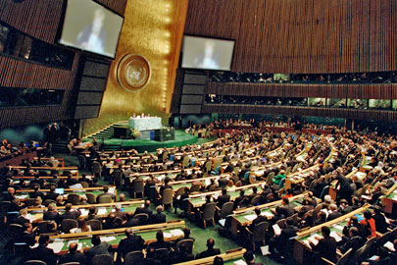
http://www.un.org/en/ga/

Topic Area: Freedom of Expression and Access to the Media
__________________________________________________________________
Introduction –
This study guide is intended to give you an overview of the situation regarding freedom of expression and access to the media worldwide. It is a starting point for your own research and your preparations for the PMUN conference. You will need to research your own country with respect to this issue.

Topic Overview –
According to the Universal Declaration of Human Rights, Article 19, freedom of expression is considered a fundamental human right.
“Everyone has the right to freedom of opinion and expression; this right includes the freedom to hold opinions without interference and to seek, receive, and impart information and ideas through any media and regardless of frontiers.”
Source: United Nations, Universal Declaration of Human Rights
The ability for individuals to be able to secure media freedom and access to information all ties into the greater goal of empowering populations in the current age. Without this empowerment, people often times become subject to intense political and social struggles that restrict them from living meaningful lives. The right of people to participate in their communities can only be achieved once the truth is fully revealed. The achievement of this comes once accurate, fair and unbiased information that represents a plurality of opinions is presented to all, and the means for communicating among regional and global circles is available.
Providing these services however is much easier said than accomplished. There are a variety of parameters that must be in place including, but not limited to:
-“a legal and regulatory environment that allows for an open and pluralistic media sector to emerge;
-a political will to support the sector and a rule of law to protect it;
-laws ensuring access to information, especially information in the public domain, and;
-the necessary media literacy skills among news consumers to critically analyze and synthesize the information they receive to use it in their daily lives and to hold the media accountable for its actions” (United Nations World Press Freedom Day 2013).
These items, in accordance with media professionals adhering to the basic standards of ethics and morality, are essential in creating the social infrastructure necessary for there to be true freedom of expression and access to the media.
There are many countries and communities throughout the world who have yet to provide these fundamental rights for its citizens. In fact, in 2011 alone, there were 66 journalists killed, 71 journalists kidnapped, 1,044 journalists arrested, 1,959 journalists physically attacked or threatened, 499 media censored, and 69 countries subject to Internet censorship. This information was provided by the non-profit organization of Reporters Without Borders that has the specific interest of the media to report truthfully and without restrictions worldwide. This organization has correspondents in over 150 countries and is continuously working to build relations with the United Nations to make a difference once and for all.

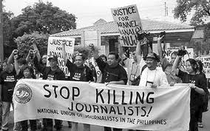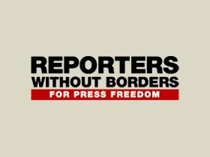
http://freebreakingnews.org/tag/saddam-hussein/ http://www.libyaherald.com/2013/

Where it matters? –
The unfortunate reality of freedom of expression and access to the media is that while many countries claim to adhere to UN Declaration of Human Rights, there is not a single country where these rights remain completely unrestricted. Each day there are billions of people who are limited in their outward communication, opinions, and speech. The creation of the Internet has only intensified this problem as social media websites are regulated and censored differently than their print and video counterparts. People now feel more comfortable in some cultures speaking out anonymously on media sites such as Twitter to voice their opinions, and in some cases, it is their only option.
In today’s technological world, the media provides people with an opportunity to receive and share information instantaneously. It is a vital component of the world that we live in and the fact that some individuals cannot access it impinges on the progress that has been made in the 21st century. The issues of access to the media and freedom of expression cannot be ignored. So how can it be provided to all people?

Questions to consider -
- To what extent are governments justified in regulating the expression of their people?
- Does the international community have the right to become involved?
- Who determines what is accessible in the media?
- Should there be any limits on personal expression?
- How will the UN convince states to hold true to their agreement of the Universal Declaration of Human Rights?
- Will the negotiations necessary between governments and the UN be successful in providing these basic human rights?
Helpful Resources for Students:

SOCHUM Committee UN Webpage
http://www.un.org/en/ga/third/index.shtml

The Universal Declaration of Human Rights
http://www.un.org/en/documents/udhr/

UNESCO: Freedom of Expression
http://www.unesco.org/new/en/communication-and-information/freedom-of-expression/

The World Factbook
https://www.cia.gov/library/publications/the-world-factbook/

Amnesty International
http://www.amnestyusa.org/

Reporters Without Borders
http://en.rsf.org/

**News articles regarding your country and this issue**

United Nations. "UN General Assembly - Third Committee - Social, Humanitarian & Cultural." UN News Center. UN, 18 Sept. 2012.
United Nations. "Press, News, Journalists, Journalism, Freedom, Reporting, Censorship, Expression, Media, Governance, Democracy, Democratic, Windhoek, UNESCO, United Nations." UN News Center. UN, 2013. Web. 14 Feb. 2013.
United Nations. "Press, News, Journalists, Journalism, Freedom, Reporting, Censorship, Expression, Media, Governance, Democracy, Democratic, Windhoek, UNESCO, United Nations.”
Reporters Without Borders. "Who We Are ? - Reporters Without Borders." Who We Are ? N.p., 12 Sept. 2012. Web. 14 Feb. 2013.

