BS Art-Education K-12
NAME___________________________________________________
Minor: (13-18 elective credits)
Check off what you have taken:
1st Year Requirements: General Education:
1ST Year Experience Courses  Required |  |  | Year 1  Major Required Courses
EN1400 | Composition |  | AE 1000 | Intro to Art Education
MA____ | Math Foundations |  | AH 1130 | Art History Foundations: 12 Monuments
IS1111 | First Year Seminar |  | AH 1140 | Art History Foundations: Visual Culture
 |  |  | AR1045 | Art Foundations 2D: Composition and Content
 |  |  | AR 1065 | Art Foundations: 3D Materials and Meaning
 |  |  | AR 1075 | Art Foundations: Line and Language
Attribute
Past & Present
Direction
Scientific Inquiry
Direction
Self & Society
Direction
Additional Directions
courses, totaling 16 DI
credits

2nd Year Requirements:

Year 2
Major Recommended Courses
AE2000 | Foundations of Art Education
AE3050 | Methods and Materials for Art Education
AH2700 | 20/21 Art Since 1900
AR1080 | Art Foundations: Digital and New Media
AR2520 | Drawing: Figure in Value
AR3010 | Painting: Theory and Process
Ceramics Elective: (Complete 1) | AR3220 Foundations of Ceramics: Exploration OR  AR3230 Foundation of Ceramics: Wheel Explorations
AR3295 | Printmaking Foundations: Cut, Carve, Etch
Make sure you have at least 15 credits (5 courses min).

To complete a full schedule fill in with:
General Education Courses (Directions or Connections)
Minor courses
Other courses of interest

SCHEDULE WORKSHEET
 | CRN | Course ID | TITLE | Cr. | Days | Times
1
2
3
4
5

PIN#________________________________ Registration Date: ______
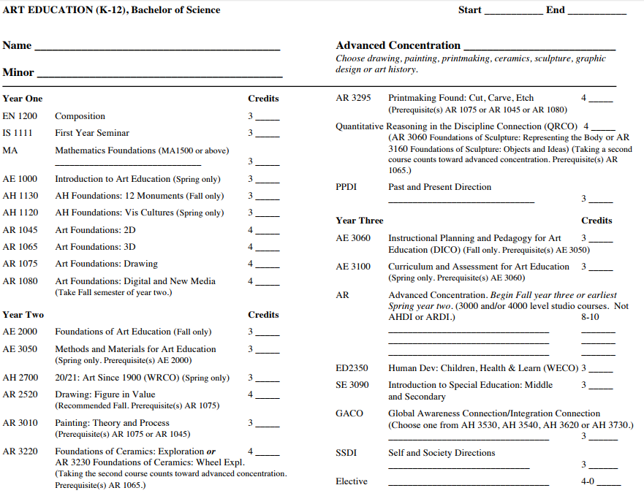
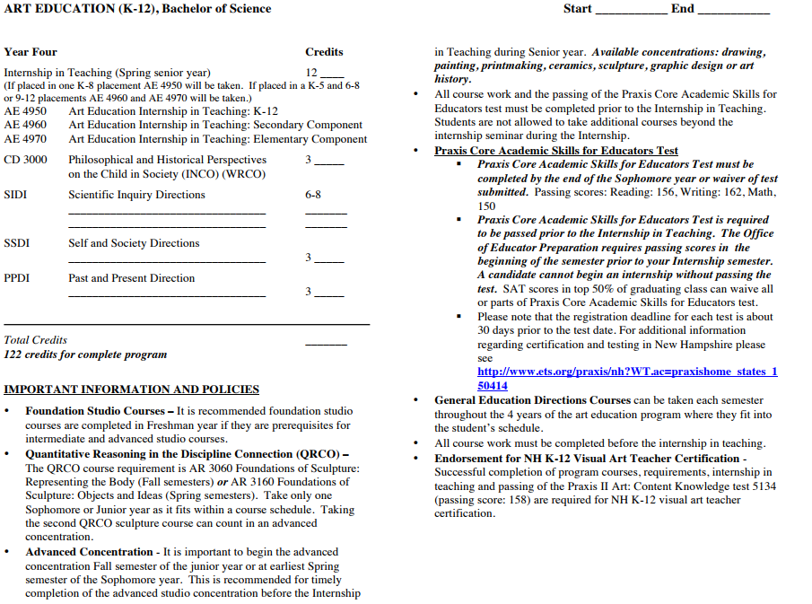
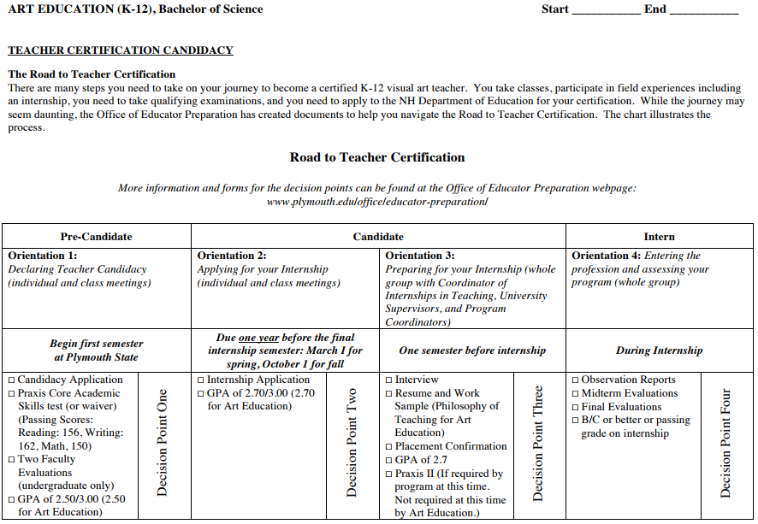

Praxis Core Academic Skills for Educators Test
- Praxis Core Academic Skills for Educators Test must be completed by the end of the Sophomore year or waiver of test submitted. Passing scores:Reading: 156, Writing: 162, Math, 150
- Praxis Core Academic Skills for Educators Test is required to be passed prior to the Internship in Teaching. The Office of Educator Preparation requires passing scores in the beginning of the semester prior to your Internship semester. A candidate cannot begin an internship without passing the test. SAT scores in top 50% of graduating class can waive all or parts of Praxis Core Academic Skills for Educators test.
- Please note that the registration deadline for each test is about 30 days prior to the test date. For additional information regarding certification and testing in New Hampshire please see http://www.ets.org/praxis/nh?WT.ac=praxishome_states_150414

