Elementary Education K-6/8
NAME___________________________________________________
Concentration (if K-8): (17-19 credits)
Check off what you have taken:
1st Year Spring Semester General Education:
1ST Year Experience Courses  Required |  |  | Major Required Courses
EN1400 | Composition |  | CD1000 | Children and Families in Schools and Communities
MA2110 | Math Foundations  PreK-3 for Educators |  | MA2120 | Mathematics for Grades 4-6 Educators
IS1111 | First Year Seminar
Attribute
Creative Thought Direction
Past & Present
Direction
Scientific Inquiry
Direction
Self & Society
Direction
1-2 Additional Directions courses, totaling 20 DI credit
Global Awareness
Connection

2nd Year
Year 2
Major Recommended Courses
ED2350 | Child and Youth Health and Development in Context  (Recommended to take in Fall)
CD2360 | Foundations of Diversity  (Recommended to take in Fall)
ED2500 | Learning and Development  (Recommended to take in Spring)
SE2080 | Children and Youth with Disabilities  (Recommended to take in Spring)
To complete a full schedule fill in with:
* Make sure you have at least 15 credits (5 courses minimum)
* In order to become K-8 Certified you must take 9 credits towards a desired content (ie: English Language Arts, Math, Science or Social Studies) and pass a Praxis II exam in that area. These must be in addition to General Education Courses. The easiest way to do this is to declare a minor. If you have questions about this, please meet with an EEYD faculty member.
* If you intend on completing the K-8 certification, please visit the Elementary Education Moodle page and fill out the required form
*See below for information on Praxis and Teacher Certification (note: students in Elementary Education need to pass the Praxis Core by September 15th for spring cohort admission and January 15th for fall cohort admission.
*If you plan to study abroad, please make sure you meet up with an EEYD faculty member.

SCHEDULE WORKSHEET
 | Course # | Gen  Ed | TITLE | Cr. | CRN | Days | Times
1
2
3
4
5

PIN#________________________________ Registration Date: ______at 9:00AM

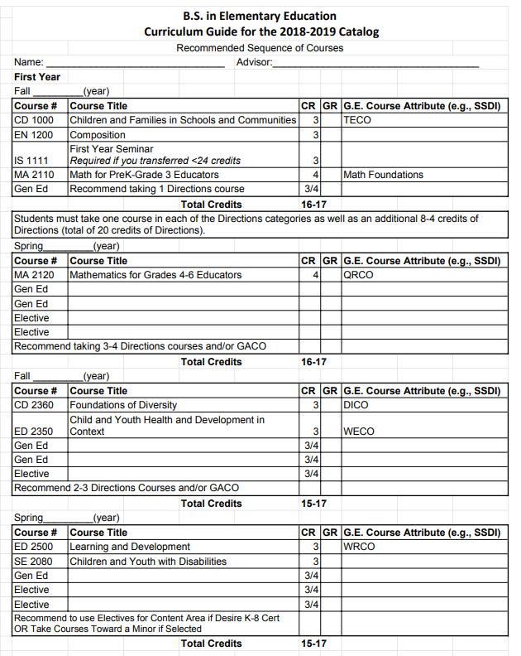

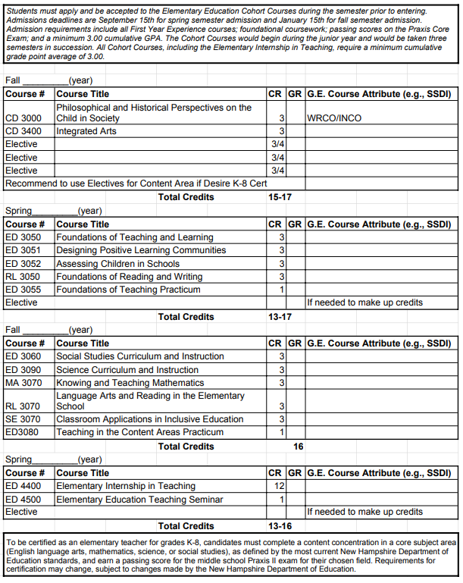
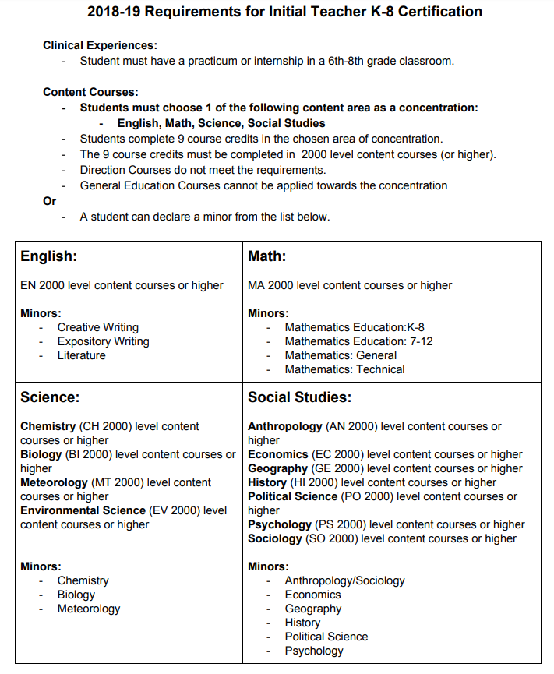
THE ROAD TO TEACHER CERTIFICATION
Visit this website to learn more about Praxis, Praxis waiver forms, and teacher certification

https://campus.plymouth.edu/educator-preparation/the-road-to-teacher-
certification/

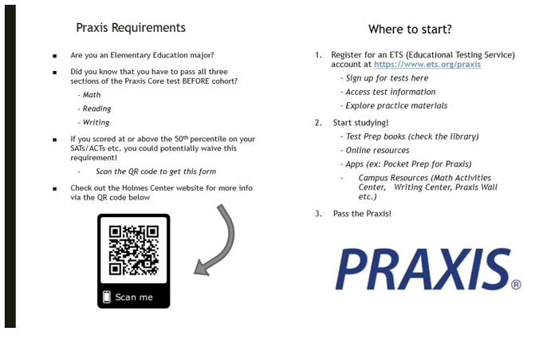

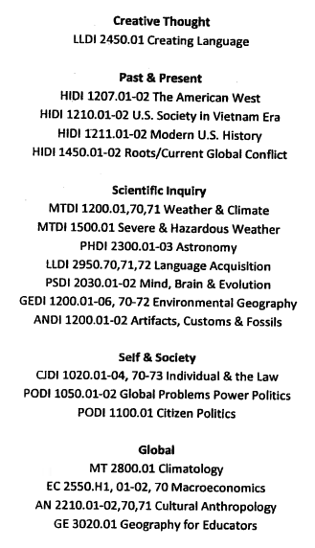
The below classes are some suggested General Education Courses that may help with the Praxis exam. They are suggested not required.

